Conference funding requests must be presented at a LAI-GSA meeting one month prior to the conference. No exceptions will be allowed. All forms must be submitted by email to laigsa@buffalo.edu. Hard copies will not be accepted.
NOTE: If you waive your student activity fee, you are not eligible for Conference Funding from the LAI-GSA or Big GSA.
Name:
Email:
Address:
Phone:

Name of Conference:
Date of Conference:
Location:
Title of Presentation:
(If attending only, put ATTENDING)
NOTE: If you are approved for funding and you do not attend the conference, you are no longer eligible for funding. You must notify laigsa@buffalo.edu and Stephanie George at slfrank@buffalo.edu that you have not attended the conference and will not be receiving funding.
Are you requesting funding from GSA as well? __Yes __ No
Signature of Student: |  | Date

PROJECTED BUDGET
Description of Expenditures | Estimated Expenses
Registration Fee
Lodging
Travel
Presentation Materials
Estimated Total Expenses
Funding Allocation
(To be completed by LAI GSA Treasurer)

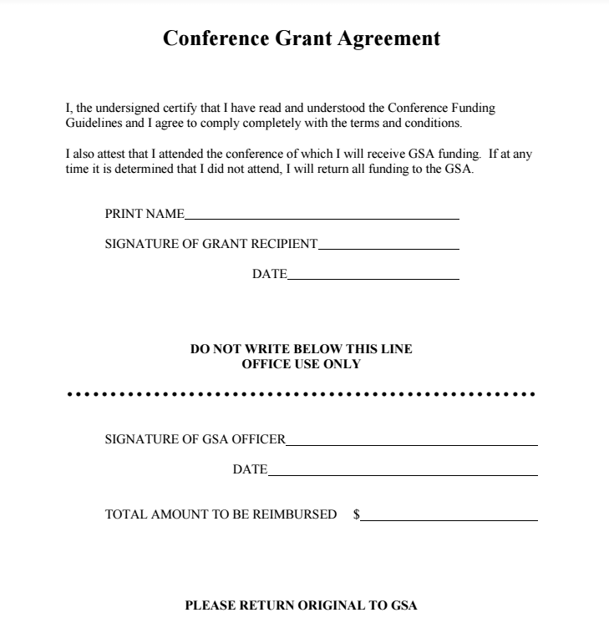
310 Student Union

