CPS Titanium User Manual for
Client Management

Western Carolina University
Counseling and Psychological Services (CPS)
Scheduling and Electronic Medical Records

By Michelle Cooper, Ph.D.

Table of Contents
Training Outline: 5
Overall Responsibilities 5
Daily Workflow 5
Introduction 6
HELP! I can’t remember how to… 6
User Configuration 7
Titanium Tools - Overview 8
Scheduling Screen and General Navigation 9
Columns 9
Rows 9
Scheduler Buttons 9
Scheduler Navigation 9
Text Editing 10
Types of Appointments: 10
Place Holders vs. Appointments 11
Typical Placeholder Practice 11
How to Schedule Individual Appointments and Placeholders 12
Individual Appointment Definition 12
Scheduling an Appointment or Placeholder 12
Editing an Appointment or Placeholder 13
Deleting an Appointment or Placeholder 13
How to Quickly Change the Time of an Existing Appointment or Placeholder 13
Moving an Appointment or Placeholder 13
Copying an appointments or placeholders 13
Attendance 14
Client Database 15
Search for Client 15
Client Information –Contact Information & Security 16
Client File 17
Case Notes for Individual Appointments 18
How to write a New note for an Individual Appointment 18
Case Notes – How to Enter a Diagnosis 19
Case Notes – Signing, Un-Signing, Forwarding and Locking 20
Signing a Note 20
UN-Signing a Note 20
Forwarding a Note 20
Locking a Note 20
Case Notes – How to create an Addendum to an existing Case Note 21
Case Notes for Termination / Transfer of Services 22
Case Management Follow-up Appointments 23
Scheduling Case Management Appointment 23
Selecting Form Letter template for Case Management Activity and Sending Email Follow-up 23
Documenting E-mail Follow-up in Titanium 24
Case Note Types to Use for Each Appointment Type 25
Data Forms 26
Attachments 27
Task List 28
My Clients 29
ADVANCED FUNCTIONS 30
Group Sign Up Sheets 30
How to Schedule Group and Couples Appointments 30
Group/Couple Appointment Definition 30
Group/Couples Appointment Scheduling Overview 31
How to Schedule a Group or Couples Appointment 31
How to Handle Attendance for a Group/Couples Appointment 32
How to Write Group and Couples Notes 33
How to add individual notes to a distributed group/couples note 33
How to add complete a termination note for group clients. 34
How to document a Couples Initial Assessment 34
How to add complete a termination note for couples clients. 35
How to Use Form Letters 35
How to Send and Document E-mail to an Individual Client 35
How to Send and Document E-mail to a Group of Students 36
Supervision of Trainees 37
Responsibilities 37
Reviewing Supervisee’s Notes 37
Adding an Addendum to a Supervisee’s Note 37
Case Review of Clinical Records 38
Scheduling Other Non-Clinical Activities 39
Adding Yourself to an Existing Appointment 39
Placing A “Generic” Non-Clinical Activity in Your Schedule 40
Placing A “Service-Related” Non-Clinical Activity in Your Schedule 41
Appointment Codes Requiring “Additional Information” 42
After Service Is Completed: 42
Changing Your Password in Titanium Schedule 48

Training Outline:  - Intro  - Confidentiality & privacy  - Activity logs  - Research data – accuracy  - Timeliness  - Demonstrate, validate, report  - CCMH  - Help – F1 – or help file  - User Configuration – scheduler layout, defaults  - Schedule & Navigation Overview  - Appointment Types  - Appointments vs. placeholders  - Scheduling shared appointments  - How to schedule individual appointments  - Re-schedule, move, and copy  - Client Database – Clinical Need ONLY  - Search  - Client Information  - Client File Overview  - Case Note Overview  - Case Notes  - Data Forms  - Attachments  - Task List  - Advanced Functions  - Group Sign Up Sheets  - Scheduling groups or couples  - Group Evaluations  - Group/couple attendance & notes  - Non-client Notes  - Supervision | Overall Responsibilities  - Manage your schedule (scheduling, attendance, etc.)  - Manage your Task List (write your notes, forward to supervisors, complete attendance, complete additional information for non-clinical activity.)  - Manage your My Clients list (who are you currently working with)  Daily Workflow  - Schedule appointment  - Review Client File and Contact Information  - Notes, Data Forms, Attachments  - See client  - Set appointment attendance  - Go to Task List & write Case Note  - Data Forms  - Attachments  - Diagnosis  - Sign Case Note and forward to Supervisor

Introduction
Titanium is the informational backbone of CPS and must be used carefully and professionally in accordance with all standard professional ethics:
- CPS is practically a paperless office. Titanium stores ALL client information including contact information, demographics, appointments, appointment histories, and case-files (i.e., all case notes). All paper forms are scanned into Titanium as well.
- Titanium provides the data used by CPS staff to demonstrate, validate, market, and lobby for the work we do – and therefore relates to funding, staffing levels, and much more.
- The information contained in Titanium represents highly sensitive and confidential medical-legal records for thousands of clients. Please treat this information as you would like your own records to be treated.
Guiding Principles for using Titanium:
- EVERY client appointment must be accurately scheduled and attended (i.e., show, no-show, cancel).
- Anything you enter into Titanium is both clinical data, legal data and research data – be sure it is accurate
- Trainees and staff are expected to have their recordkeeping responsibilities fully completed (meaning all assigned records have had final favorable case review) BEFORE their term is up. Supervisors are expected to check regularly to be sure that appointment and record-keeping is up-to-date. See CPS Policies and Procedures manual for more information.
- Client files should only be accessed when there is a clinical need.

HELP! I can’t remember how to…
Titanium has an award winning help system if you’ve forgotten a basic step. To answer your question:
- Press F1 or choose “Help” from the pull-down help menu.
  - 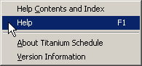
- Ask anyone at CPS (Michelle and Mike are the gurus)

User Configuration – define how Titanium appears to you.  Titanium Timesaver Tip:  Customize your Titanium to suit your preferences… so you can see just your schedule, a longer work-day… whatever suits you! | 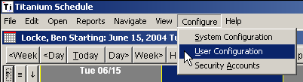
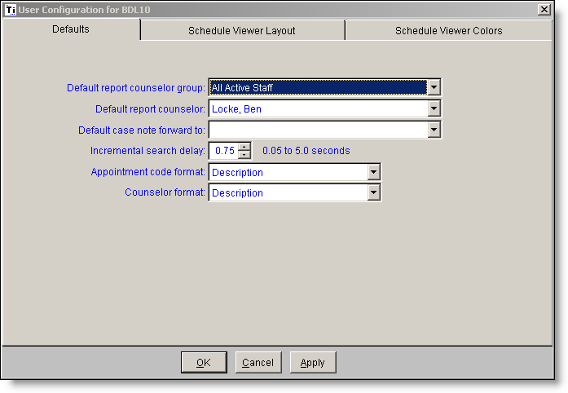  Defaults |  | 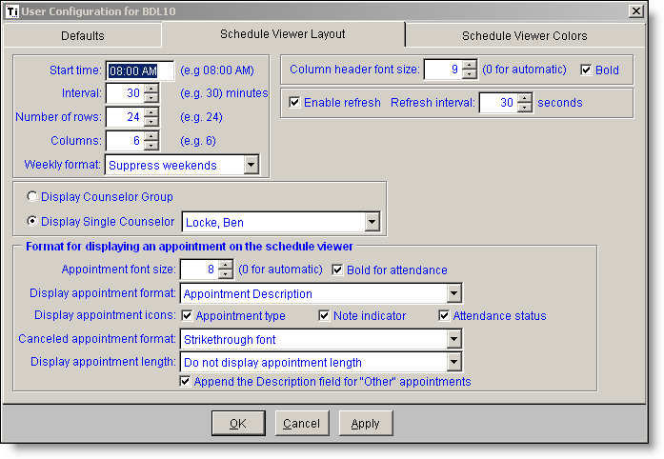  Scheduler Viewer Layout
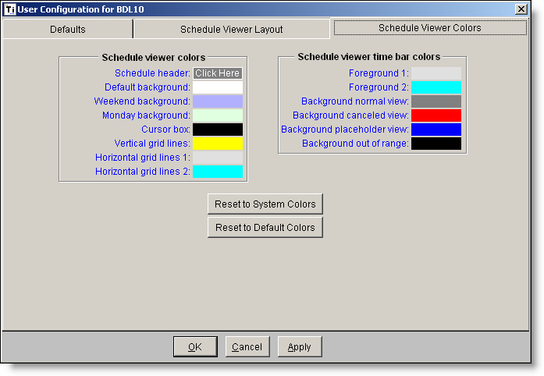  Scheduler Viewer Colors |  | - Key Setting in Defaults  - Default Case Note Forward to: This is primarily used by trainees to set a default supervisor. This will autofill this field in the case note after the note is signed by the trainee and can be changed if needed.  - Key Settings in Scheduler Viewer Layout:  - # of Columns displayed  - “Display Single Counselor” – this will set the default counselor screen.  - “Display Appointment Format” – alter how appointments are displayed including whether Client names are displayed in the scheduler. Client names should ONLY be displayed if confidentiality is not a problem with your computer screen.

Titanium Tools - Overview
Titanium represents a suite of tools that enable you to handle the large majority of scheduling and filing aspects of your clinical work at CPS.

- Accessible from the “Open” drop down menu  - Task List - a list of all the client notes you need to attend to.  - My Clients - a list of all clients assigned to you.  - Case File – all records for a given client  - Case Notes – the screen for writing, signing, reviewing a specific note within a case file.  - Approve Incoming Data – front desk only (web data entry)  - Schedule (unused)  - Clients – search for any client  - Advanced Client Search  - Non-Client Notes – (unused @ WCU)  - Group Sign Up Sheets – for keeping a list of group members that can be copied into a group appointment roster. See “How to Schedule Group and Couples Appointments”. | 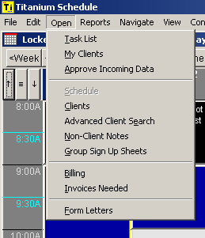

Scheduling Screen and General Navigation

Columns
Titanium Tip:
To switch between your individual schedule and everyone else’s schedules, right-click on your name-bar and you can toggle between individual / group views.
User names within a group or days of the week.

Rows
Time increments by the ½ hour

Scheduler Buttons
Time/Date Navigation
Use these buttons:
Home Button
Brings up your schedule with today’s day in the far left column.
Go To… Button
Go to a specific date and/or counselor.
Find Button
Find a client and their appointment history. Often used to quickly find the next appointment for a client.
Find Open Button
Used by find the next open placeholder for specific appointments (intake, group eval, psych eval, crisis). This functionality doesn’t work unless staff enters their placeholders correctly.
Navigating provider schedules and provider groups
Use these buttons (first, next left, next right, and last) to move within a provider group which you choose with the drop down menu.
ICONS
  - Type of appointment (one face or two)
  - Appointment or client notes
  - Attendance (scheduled, attended, no show, client cancel, counselor cancel)

Scheduler Navigation
- Mouse Clicking:
  - Right Clicking – brings up a menu of options.
  - Left clicking – opens the item clicked on.
- Mouse over appointments to see more information about the appointment.
- “View” drop down menu…

Text Editing
- Almost any text area that you type in provides the ability to (1) Expand it to the full screen for editing, (2) spell checking, and (3) inserting a template of text (usually used for case notes). To access these features, just right-click within the text field. Here’s what the menu will look like:
  - 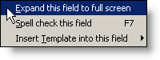
  - You can also use the F7 key to spell check the field you are in.

Types of Appointments:

- Individual – any appointment for one client. You MUST choose a client. Also used for case management functions documented in one client’s record.
- Group/Couples – any appointment for more than one client. Also used for case management functions for multiple clients simultaneously (e.g. sending a blind-copy group e-mail.)
- Other – any appointment that DOES NOT contain a client.

Place Holders vs. Appointments
Think of placeholders and appointments as two layers with placeholders on the bottom and appointments on top.
Placeholders are used to reserve time for regularly used time blocks (initial assessments, personal counseling, emergency consultation initials, lunch, after-hour on-call, withdrawal-related). Most importantly, they are searched by the front desk to find “the next available” of a specific appointment type. A placeholder is considered unavailable if it is covered by any type of appointment. For example, if a crisis placeholder is covered by a vacation appointment, it will not be “found” in the “Find Open” search. Placeholders are generally NOT linked to a client and our agency’s practice is not insert names into placeholders. Appointments are actual events scheduled with people or places – and they cover placeholders. Appointments can be the same or different as the placeholders they cover.

Create one placeholder (with start/end date) for each hour of your schedule for each semester. DO NOT EVER CREATE RECURRING PLACEHOLDERS EVER AS IT WILL INTERFERE WITH SCHEDULING PROCEDURES.

Typical Placeholder Practice
Most of the time, you will be scheduling appointments instead of placeholders. However, in order to prevent covering up a clinical placeholder, one must never create or modify “recurring” appointments after the semester schedule has been set. At the start of each semester, a set number of placeholders are placed in each clinician’s schedule in accordance with their workload expectations. While all trainees will use personal counseling placeholders, senior staff may choose to use them but should inform the Front Desk to avoid overbooking.

Typical Placeholders | Purpose
ER Initial | @ 11am & 3pm for daytime on-call and back-up
Initial Assessment | @ pre-set times per master schedule set by first week of semester (for entire semester)
MH Withdrawal Consultation | During last 3-4 days preceding MH withdrawal deadline
RAF Initial | One per week for Substance Abuse Specialist; others as directed
Case Manager- Direct | 1-2 per week for Case Manager; Clinical Director serves as back-up
After Hours On-Call | At end of day for after hours primary/back-up on-call person
Personal Counseling | Required for all clinical staff; schedule within 1st week of semester for entire semester.
Lunch / Staff Meetings | Optional; helps to avoid covering up clinical placeholders
All Groups | Placeholders are used instead of appointments until group actually forms/meets

How to Schedule Individual Appointments and Placeholders

Individual Appointment Definition
An “individual appointment” will ALWAYS have an existing client associated with it. You cannot schedule an individual appointment without choosing a client. DO NOT CREATE A PLACEHOLDER FOR AN INDIVIDUAL APPOINTMENT.

APPOINTMENT  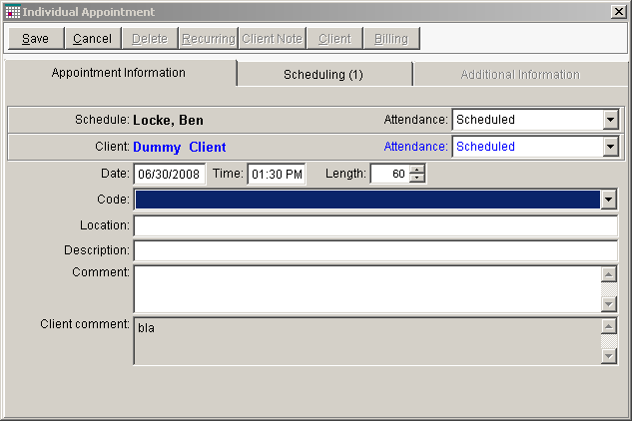 | PLACEHOLDER  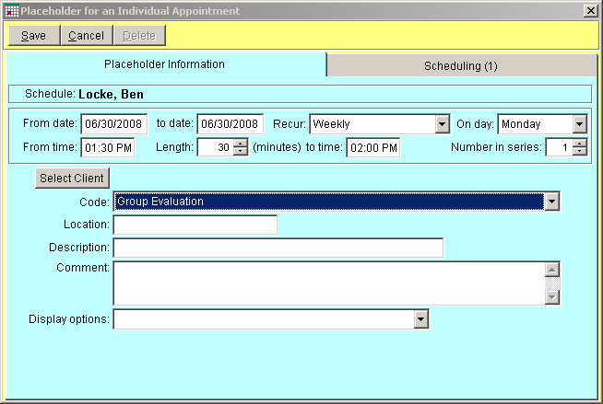

Scheduling an Appointment or Placeholder
Scheduling appointments and placeholders is the same process except: (1) appointments MUST be linked to a client and (2) placeholders are not linked to a client. Only the front-desk schedules new clients!
- Right or left click at the time you wish to schedule. Choose the client, if appropriate.
- Verify time and date
- Verify attendees (i.e.,the scheduling tab)
  - Keep in mind – each counselor will have the appointment on their schedule
  - ROOMS – Be sure to schedule the room that you will be using.
- Choose appropriate code
- DESCRIPTION Field – text entered here will be displayed on the appointment in the schedule (e.g., “Returning”)
- Save/Exit.

Editing an Appointment or Placeholder
- Open appointment (right or left click)
- Click on “Edit”.
- Make changes
- Save/Exit.

Deleting an Appointment or Placeholder
- Open appointment (right or left click)
- Click on “Delete”.
- Save/Exit.

How to Quickly Change the Time of an Existing Appointment or Placeholder

- Hover your mouse over the bottom line of an appointment.  - When the cursor changes to an up/down arrow, click, and drag to the desired time. | 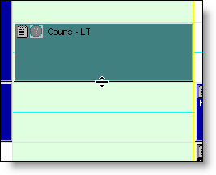

Moving an Appointment or Placeholder
- Open the appointment and edit OR Drag and Drop appointment to desired time
- DO NOT DRAG AND DROP RESCHEDULED APPOINTMENTS!
  - Client Calls to Cancel and Reschedule
  - Cancel first appointment
  - Find/create new appointment

Copying an appointments or placeholders
- Right click the appointment
  - Copy
  - Copy to Next week
- Right click and drag the appointment to where you want.

Attendance
- Right click on the appointment, go to attendance and choose appropriate selection.

Client Database

Search for Client

- Enables you to search for a client in the database.
  - Enter as much information as you have
  - Portion of ID number
  - First letter of last name, and first two letters of first name
  - To look for a misspelled name, use the minimum amount of information to search.
  - DUPLICATE ENTRIES – bring to the attention of Michelle or Lisa.
  - All matching entries will be displayed.
Double Click on the desired entry to go to the client screen.
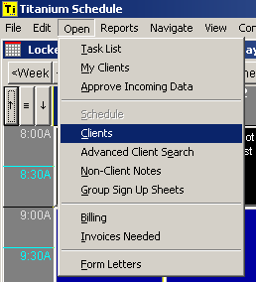 | 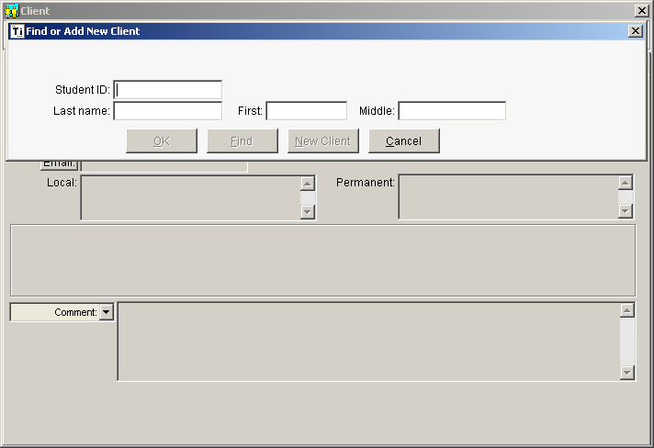

Client Information –Contact Information & Security
- Save/Exit – Save your changes/exit the client screen.  - Edit/Cancel – Make changes/Cancel changes  - New  - Delete  - Find – to find another client case file.  - History/File | - 2 Tabs  - Contact Information – Verify accurate contact information, including consent to communicate for scheduling purposes.  Status = Therapist of Record (who keeps physical chart)  - Client Security – Contains all clinicians who have been assigned to provide a service for client (ER, ongoing counseling, psychiatric, biofeedback, group, etc.)
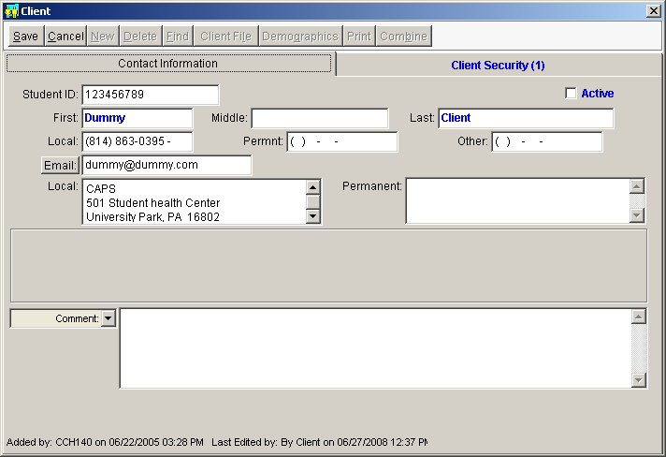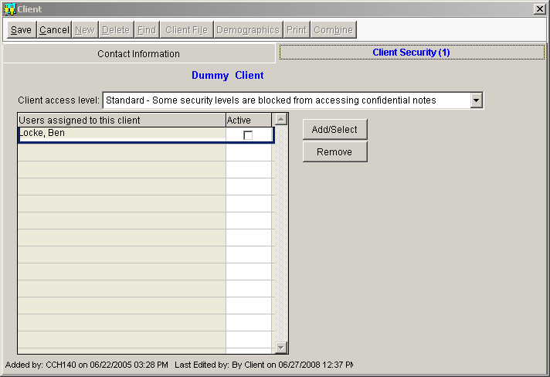

Client File
Electronic Medical Record: Appointments, Notes, Scanned Documents, Data Forms, etc.

- MADE UP OF:  - Notes  - Appointments  - Attachments  - Diagnoses  - Data Forms  - Exit – to return to the previous screen.  - Find Client – to find another client case file.  - Open – open a specific item.  - New Note to create a new note (that is NOT associated with an appointment)  - Print – To print all or a portion of case notes/ history and diagnoses  - Demographics: Most recent demographics  - View CCAPS – View the most recent CCAPS.  - Filter: Filter the files by type of item.  - Double click – to open any specific note or appointment | 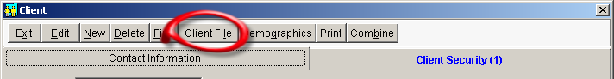  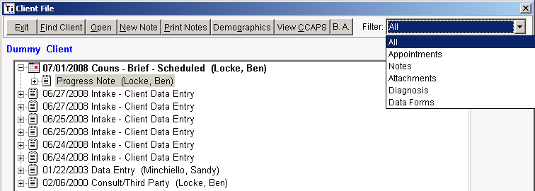

Case Notes for Individual Appointments
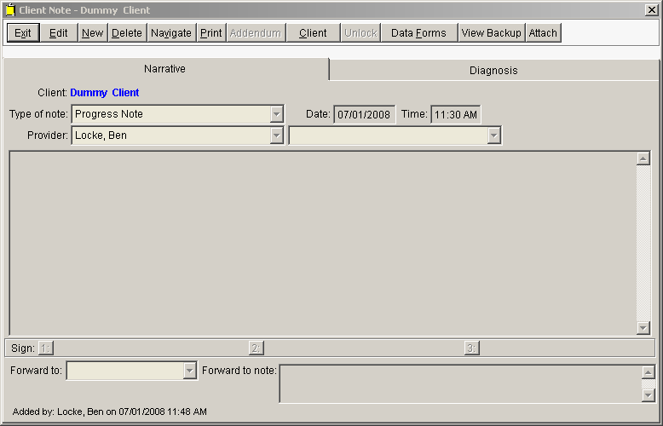 | - Save/Exit  - Edit/Cancel  - New  - Delete  - Navigate (go to another note)  - Print  - Addendum  - Client (go to contact information)  - Unlock (system admins only)  - Data Forms  - View Backup (if red)  - Attach  - Distribute (group notes only)  - Tabs  - Narrative  - Diagnosis (DSM)

How to write a New note for an Individual Appointment
  - Verify accuracy or select the type of Note
  - Verify Date/Time
  - Verify Counselor 1 and 2 (if any)
  - Choose Note template (if desired) or Note dataform, depending upon the type of case note.
Case Notes Requiring Dataform= All Emergency-related appointments, Initial Assessments (individual / couples), MH Course Withdrawal, MH University Withdrawal
  - Type note (double click to expand any text field)
  - Enter diagnosis (if applicable) on diagnosis tab (diagnosis completed for all initials, terminations, psychiatric and when clinically relevant)
    - Sign, forward, and/or lock the note. (See section on Signing, Forwarding, and Locking for details)

Case Notes – How to Enter a Diagnosis – How to enter/view diagnoses for a given note.
Before a diagnosis is entered: 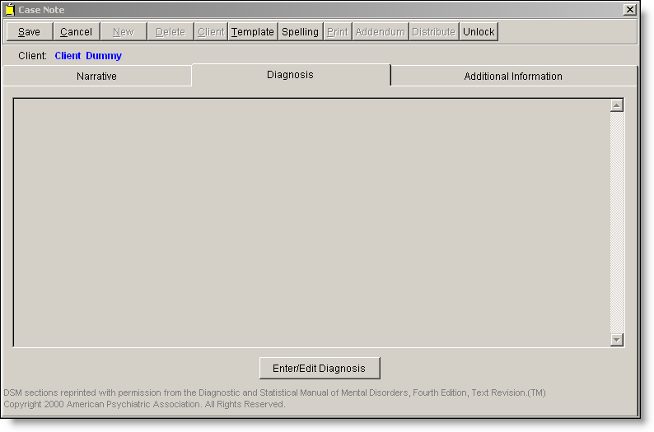  After a diagnosis is entered  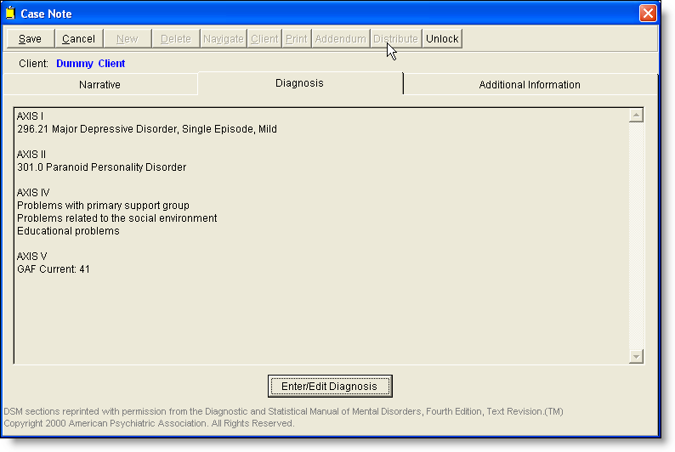 | 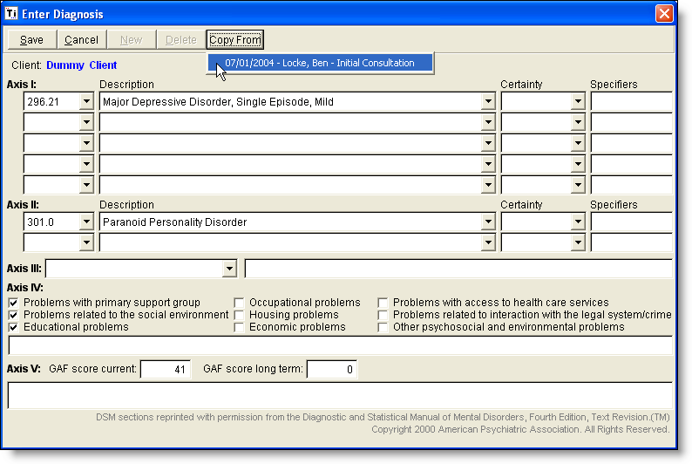
- How to Enter/Edit a diagnosis  - Click on “Enter/Edit Diagnosis”  - Choose the appropriate diagnosis for each axis.  - Click on “Save/Exit” OR… |  | - Copy a diagnosis from a previous note  - Click on “Copy From”  - Choose the diagnosis you would like to copy in.

Case Notes – Signing, Un-Signing, Forwarding and Locking
Signing a Note  - Case notes are “signed” by clicking on line 1 or line 2 or 3 and inserting your signature on that line and then clicking “Save”.  - Case notes are “locked” when a supervisor signs on line 3 and then “Saves” the note.  - A “locked” can only be unlocked by a system administrator (Michelle, Lisa or John)  UN-Signing a Note  - A signature can be removed if:  - It is removed by the original signer AND  - There are no higher level signatures.  - TO UNSIGN – (1) Open the note, (2) Click on “Edit”, (3) Click on the number of the signature you want to remove.  Forwarding a Note  - Notes can be forwarded whether they are signed or not.  - Locked Notes (on “3”) CAN be forwarded.  - Select the intended recipient of your note from the “Forward to” pull down menu.  - Enter a note** to the recipient, if desired.  - Click on “Save/Exit”  ** Notes that are sent back and forth between clinician and supervisor or other senior staff are not part of the electronic record and simply a means of messaging back and forth to expedite best practices in recordkeeping. Please clarify with your colleague around preferences before deleting these messages. Whomever signs the note on “3” can then remove messaging as desired. | 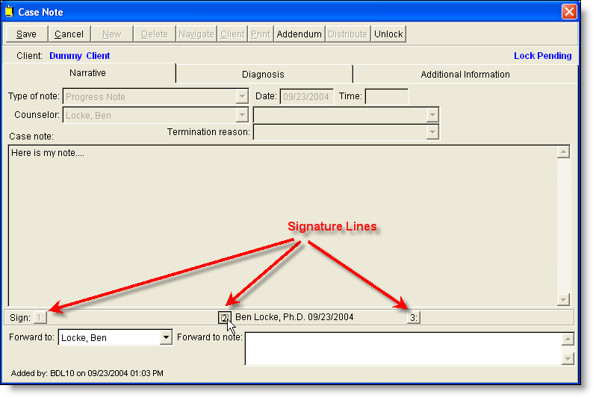  Locking a Note  - When you are ready to permanently lock a note (supervisor or unsupervised staff) – just click/sign on Line 3.  - Use the Addendum feature (in the Edit mode) to add to a previously locked note.

Case Notes – How to create an Addendum to an existing Case Note
- Navigate to the desired note: (My Clients, Case File, Open Note)  - Click on “Edit”.  - Click on “Addendum” (see picture)  - Confirm that you want to add to the existing note.  - Type your addendum  - Sign, forward, and lock as usual. | 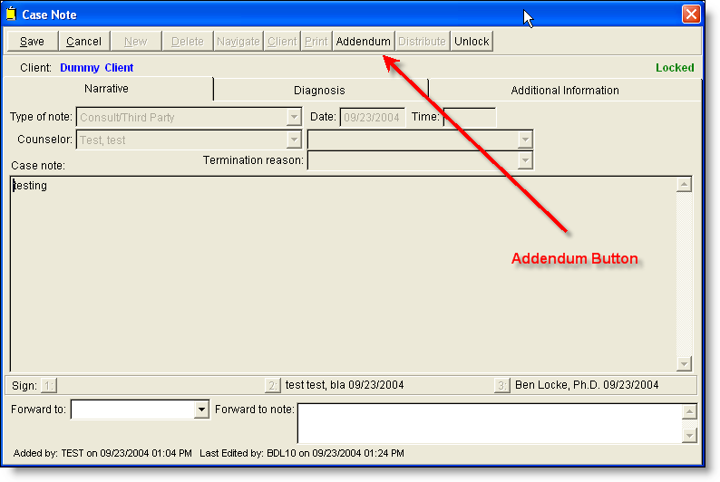  CONFIRMATION SCREEN:  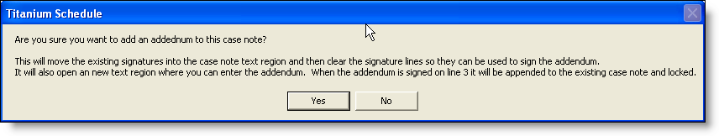

Case Notes for Termination / Transfer of Services
- On the main screen, select Open >My clients highlight the client’s name and select the Client File button from the top taskbar and then New Note.  - Select “Yes” when the warning screen is displayed.  - Select the appropriate Termination Note from the Type of Note drop down menu (see picture.)  - Select the Data Forms tab and select Termination / Closing a File data form and complete all the information. Select Save.  - If there were 4 or more personal counseling contacts during this course of treatment, a Diagnosis is required. Click on the center Diagnosis tab and then the bottom box entitled Enter/edit diagnosis [Note: Complete all five axis with a Current GAF only.] Save & Exit  Note: Trainees “sign” note [button #1] and forward to supervisor; staff sign button #3  ** MH Course Withdrawal and MH University Withdrawal contacts do not require a Termination Note as the termination is embedded within the data form. | Timesaver  Tip  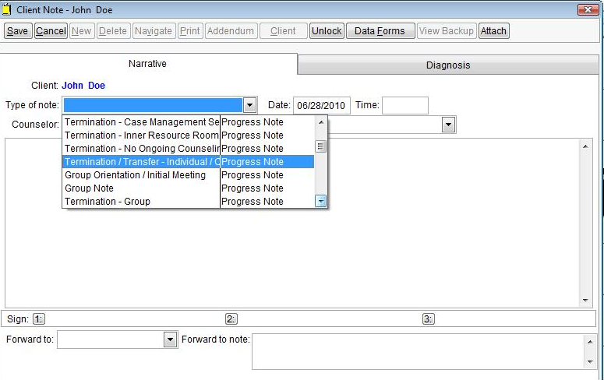  ALTERNATE METHOD- SHOWS UP ON “MY CLIENTS” AND “TASK LIST”  An alternate “appointment-based” method of terminating records can be used if the clinician wishes to have a schedule prompt to alert them of cases which need to be closed. Simply create a “*Termination/Transfer/Case Summary (or non-appt. note) appointment in your schedule. Typically these are scheduled during times which do not overlap direct service placeholders and coincide with the termination date/time per previous follow-up communication. Then, open the “client note” tab on the appointment to complete the termination note and follow the instructions on the left side bar.

Case Management Documentation (excluding Case Manager’ Direct / Indirect Service Appts.)
PLEASE NOTE THAT THE “*CM- Phone / email / Letter to / From Client” case management note is REQUIRED for the documentation of follow-up communication to and from the client. If you have received an e-mail correspondence from a client and are following up in reference to that communication, you may want to document both the message received and your response in the same case note. Also, if you need to create a prompt for yourself to contact an outside third party with regard to the ongoing counseling services you are providing or a prompt to terminate a case if the student fails to follow-up in a timely manner, you may use these appointment codes in your schedule to help you track your case management actions as appointments will actually appear on the client record tab. You can always delete the case management appointment later (for example if the student gets back on your schedule) but this is a way that clinician’s can keep on top of their case management activity within the electronic record keeping system. You may adjust the date / time to reflect the actual time spent in the case management activity. Clinicians also may create a *CM- Follow-up Email to Group of People appointment to send out group reminders, to follow-up with Inner Resource Room clients, etc. The green appt. codes are used for other purposes outlined in the P & P manual and aren’t relevant to the case management activity encompassed in ongoing counseling services.

Types of Case Management Appointments Used by Therapist of Record
*CM – Follow-up Email to Group of People
*CM- Phone / email / Letter to / From Client - REQUIRED
*CM- Consult with 3rd Party (or non-appt. note)
*Termination/Transfer/ Case Summary (or non-appt. note)
*Case Manager – Indirect Only
Titanium Timesaver Tip:
Create follow-up reminders!

Scheduling Case Management Appointment

- Right or left click at the time you wish to schedule the case management activity and select client for scheduling.
- Verify time and date
- Verify attendance as “attended.”
- Choose appropriate code “*CM- Phone/Email/Letter To / From Client” or “*CM- Consult with 3rd Party”
- Determine appropriate type of follow-up.
  - PHONE FOLLOW-UP - If you spoke briefly with the student on the phone about the scheduling follow-up or left a voicemail message (on a confidential location with consent only,) then proceed to open the “Client Note” tab and document the scheduling follow-up communication with clear instructions as to time period for follow-up before file is closed (10 – 30 day time period.) Then sign and close case note.
  - E-MAIL FOLLOW-UP – If you are about to send an e-mail follow-up, you will need to follow the two sections below which address the sending of the email and then the documentation of the correspondence.
  - CASE MANAGEMENT – If you interacted with a 3rd party to inform the care of your client, simply select the *Case Management note type and document.
- Save/Exit.

Selecting Form Letter template for Case Management Activity and Sending Email Follow-up
- Select “Open” and scroll down to select “Form Letters.”
- Select the form letter template you wish to send.
- Select the client name
- Select “Load Form and Client”

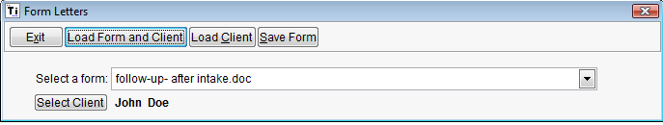

- When error message appears, select “Cancel” and form letter template with selected client’s name should appear on screen
- Highlight entire block of text and select “Ctrl-C” to copy text into an email message.
- Select “X” to exit word document and MAKE SURE THAT YOU DO NOT SAVE TEMPORARY FILE!!
- Exit the Form Letters screen.
- Open Client file for student you are about to e-mail.
- Select the “email” tab and an email message box should open up with your signature at the base of the e-mail.
- Use “Ctrl-P” to paste email follow-up template into message.
- Personalize the template and make any modifications needed (ensure that students engaged in both psychiatric services and counseling receive the extended 30 day time period for follow-up instead of the standard 10 days for counseling services alone.)
- Make sure that the “counseling-related signature” appears at bottom of e-mail message.
- Send e-mail to client.

Documenting E-mail Follow-up in Titanium
- Go to “Sent” folder in Outlook and locate the e-mail correspondence just sent to the client.
- Open the email message, block entire message and use “Ctrl-C” to copy the content of the email message (including signature with instructions.)
- Go to the “*CM- Phone/Email/Letter To / From Client” appointment and open the “Client Note.”
- In the body of the text box, use “Ctrl-P” to paste the contents of the email correspondence into the case note.
- Add any additional documentation relevant to the case management note.
- Sign and exit.

Case Note Types to Use for Each Appointment Type
Each Appointment Type corresponds with a specific type of Case Note.

Appointment Types | Case Note Types | Appointment Types cont. | Case Note Types cont.
*CM- Phone/Email/Letter To / From Client (required) | *Follow-up communication to/from client | Psychiatric Evaluation – New | Psychiatric Evaluation template
*Follow-up Email to Group of People (Group/Couples appt.) |  | Psychiatric Evaluation – Update | Psychiatric Follow-up template
*Termination (optional) Use only if you want to have reminder to complete termination in task list. | Select appropriate “type” of termination note; then select Termination / Closing a File data form. | Psychiatric Follow-up
*CM- Consult with 3rd Party | *Case Management Note template | Emergency / ER Consult- Initial | Select Crisis Assessment Report data form (see top tab)
Group Interview (Group / Couples appt.) | Group Orientation / Initial Meeting template | ER Stabilization / Follow-up | Emergency Follow-up Template
Group Session (Group / Couples appt.) | Group Note template
Initial Assessment / Update | Initial Assessment Data form plus Dx. | Personal Counseling | Session Note- select preferred template.
Initial Assessment Couples |  | Couples Counseling (Group / Couples appt.)
Initial Assessment Follow-up | Session note with reference in note body to location of formal initial assessment evaluation report. *Add Dx if used at start of new session / semester. | Case Manager – Direct / Other Direct | Therapeutic Consultation template or other relevant template.
 |  | * Case Manager - Indirect | *Case Management Note template – or other relevant template
MH Course Withdrawal | Select Withdrawal-Related Contacts data form. | RAF Initial | RAF related dataforms.
MH University Withdrawal |  | RAF Follow-up
Inner Resource Room Orientation | Biofeedback Orientation – Emwave template plus any other relevant info. | Therapeutic Consultation– In Person | Therapeutic Consultation note template is default. If the clinician desires a different format (aka SOAP, DAP) simply delete the text template and insert preferred note template.
Inner Resource Room Session | NO CASE NOTE REQUIRED UNLESS THERAPIST INVOLVED IN SESSION. | Therapeutic Consultation – Phone
*Health Center Documentation Provided | Not scheduled by clinicians; used by administration for case management tracking only. | MH Withdrawal Consultation
*Health Center Documentation Received |  | MH Withdrawal Return
*SCRT Alert or *Early Alert |  | Clinical Consultation w/clients (Group/Couples appt.)
Updated 9/7/11

Data Forms
- Data Forms store data  - Used for Initial Paperwork information (demographics, CCAPS) and certain types of case notes, etc.  - CCAPS 34 – view report or data  - Crisis Intervention Data Sheet (for ER case notes)  - Initial Assessment / Update (for routine & RAF initial assessments plus Couples initial assessments)  - Referral to Case Management (self-explanatory)  - Termination / Closing a File (for ALL Individual, Couples, Case Management, Inner Resource Room, RAF, Therapeutic Consultations, and Emergency terminations) DO NOT USE FOR COURSE WITHDRAWAL OR UNIVERSITY WITHDRAWAL.  - Withdrawal-Related Contacts (serves as documentation and termination of service)  - Client Information (SDS)  - Remaining data forms are for administrators only.  - Access from the client file, client information screen, etc. | 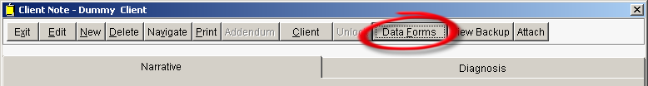  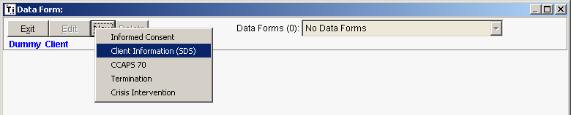  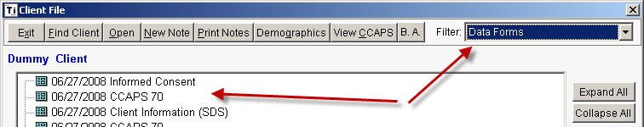

Attachments
- ALL paper materials are stored as PDF attachments  - Paper file conversion, medical records, faxes, signatures, etc.  - Access from the client file, or case note screen  - Front Desk completes all routine attachments. | 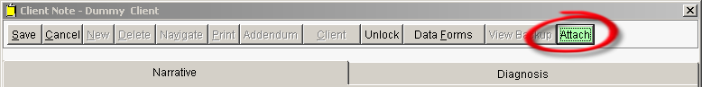  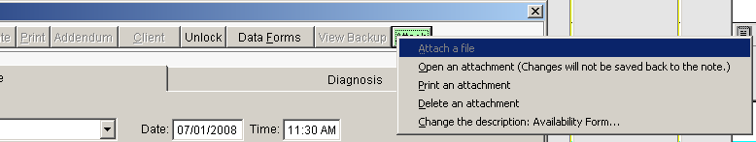  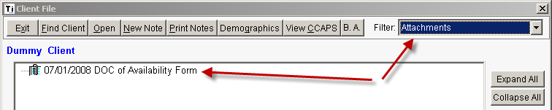

Task List – a list of (1) client notes you need to write and (2) appointments that need to have their attendance marked.
When appointments are marked “Attended” they appear on your task list to write.
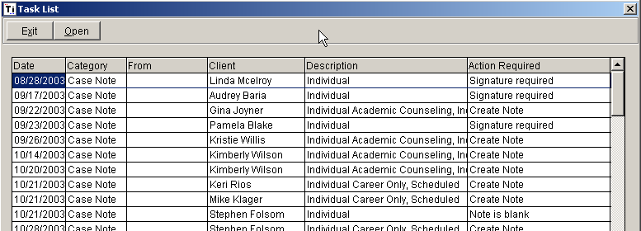

- Task List:  - Notes to write  - Past appointments with attendance status = “scheduled”  - Information available:  - Date  - Category (type of note)  - From (who forwarded it to you)  - Client Name  - Description (of appointment)  - Action Required for note | - Create Note – appointment attended – note needed.  - Note is Blank – note created but nothing entered.  - Signature Required – note has been started but not signed.  - Forward to Supervisor – Trainee signed (line 1 or 2) but not forwarded to supervisor.  - Review and Sign – Note signed by trainee and forwarded to you.  - How to use (i.e., go to a note)  - Double-click on a row to go to that case note, OR  - Click on a note, and then on “Open” button.

My Clients – a list of all clients assigned to you.
- Clients are included on your list if:  - You are listed as Counselor 1 or Counselor 2 in the Client Record  - Information Available = Client Name, Last appointment, Next Appointment, # Sessions (with you only)  - Navigation Buttons  - Exit – return to previous screen  - Client – go to the client record (i.e., address, phone, etc.)  - Appointment History- view client’s appointment history (accurate post Jan 04 only)  - Case File – go to the case files (i.e., all notes for client)  - Show clients for: Supervisors can view other’s client lists.  - How to Use:  - Select client, then click on desired button.  - Double-clicking a client goes directly to client record. | 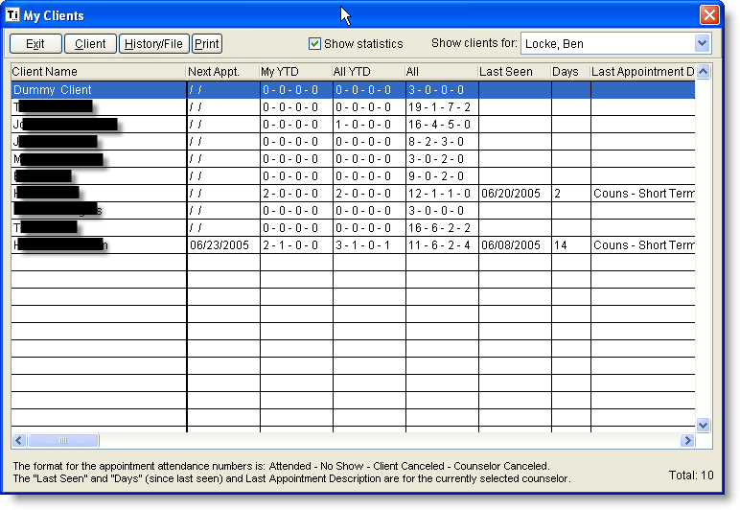

ADVANCED FUNCTIONS

Group Sign Up Sheets
- All active groups are “registered” in Titanium (name of group, facilitators, etc.) by the group coordinator each semester.
- Couples ARE NOT registered.
- Group facilitators are responsible for using the Group Registration function to maintain a current list of group members and to update the status of their group (open, closed, etc.).
- Group registration is used for:
  - A convenient place to store a list of your current group members. This list is used primarily as a short cut to fill-in group members for each group appointment (instead of adding them one-by-one).

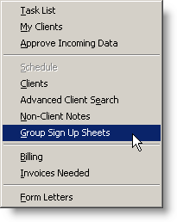 | 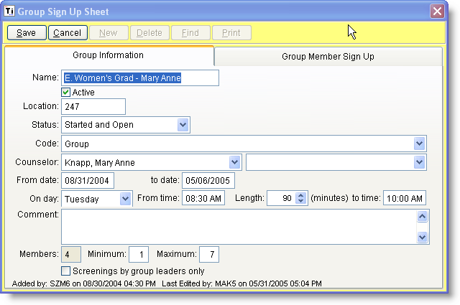 | 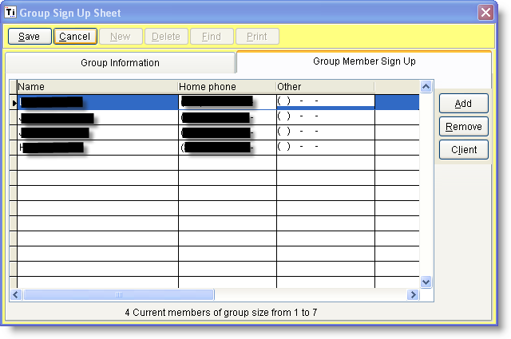

How to Schedule Group and Couples Appointments

Group/Couple Appointment Definition
- A group or couple’s appointment is used to schedule appointments with MORE THAN ONE client.
- Appointments CAN BE scheduled without specifying a client.
Group/Couples Appointment Scheduling Overview  - Group Appointments have 4 TABS;  - Group Appointment Information  - Scheduling  - Additional Information (used only for anonymous group attendance)  - Clients | 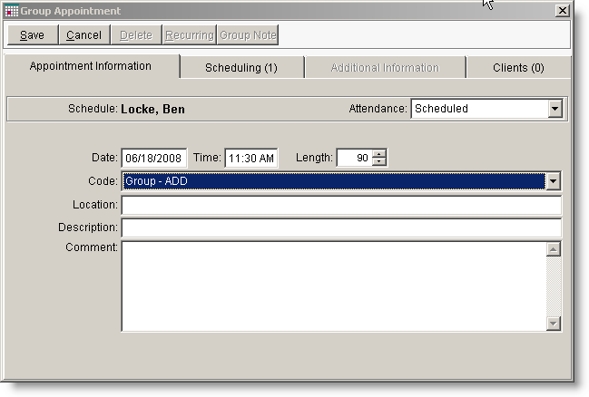

How to Schedule a Group or Couples Appointment
- Group Appointment Information:
  - Right or left click at the time you wish to schedule.
  - Verify time and date
  - Verify Schedules
    - Counselors
      - Group Appointments MUST list both counselors in one appointment (called a shared appointment) – otherwise duplicate attendance records will be created if each counselor maintains a separate appointment with each client.
    - ROOM – ALWAYS choose a room when scheduling a group
  - Choose the appropriate Group or Couples appointment code
  - Select the clients who will be attending using the “Client” tab.
    - For registered groups, you can choose the appropriate “Sign Up Sheet” and copy the members in.
    - Four couples, add both clients
- Save/Exit.

How to Handle Attendance for a Group/Couples Appointment
Group appointments have two different kinds of attendance: (1) Overall appointment attendance, and (2) individual client attendance. Both are the counselor’s responsibility!!
- Open the appointment and set the Attendance to “Attendance Taken” as appropriate.
- Click on the “Clients” tab.
- COUPLES
  - Add both members of the couple (if they are not listed)
- GROUPS:
  - Make sure the “registered group is correct on the Group Appointment Information Tab.
  - In the Clients tab - use “Copy from Registered Group” to copy in the members you have listed to your registered group.
  - Add/remove as appropriate.
- For each member, select their attendance.
- Click on Save/Exit.

CHANGES MADE IN MEMBER ATTENDANCE FOR A GROUP APPOINTMENT DOES NOT AFFECT THE GROUP Sign Up Sheets.

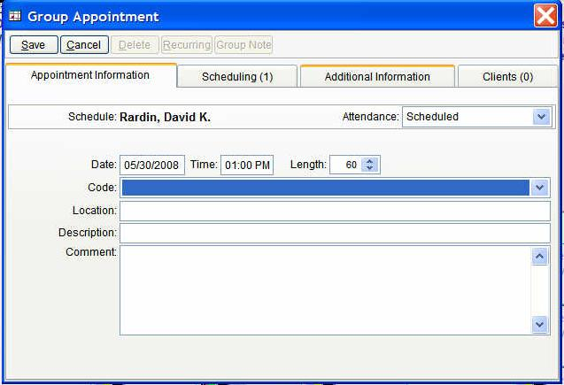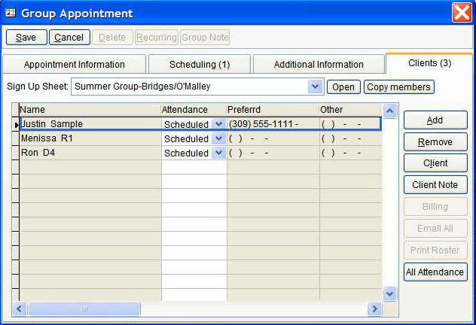

How to Write Group and Couples Notes
- Be sure attendance is completed first.
- Get to the note via your (1) Task List, or (2) the Appointment (Case Note button after attendance is done).
- Write, forward, and sign your note as usual.
- When signed/locked (usually by the supervisor) click on the “Distribute” button at the top of the group note.
- Decide whether you want to distribute to all members or only those who attended.

  - 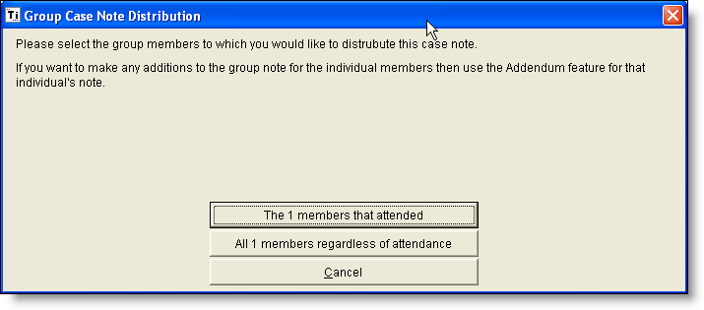

How to add individual notes to a distributed group/couples note
If you want to add an individual note to a client’s group note:
- Go to the client’s case file.
- Open the note you wish to add to.
- Click on “Edit”
- Click on “Addendum”
- Enter your individual notes to the end of the group note.
- Sign, forward, and lock as appropriate.

How to add complete a termination note for group clients.
At the end of group, you will need to create a termination note for the group:
- Go to the client’s case file.
- Open “New Note” and select “Termination – Group” type of note.
- Click on “Edit”
- Complete note section
- Select “Data Forms” tab and select “Termination / Closing A File.”
- Sign, forward, and lock as appropriate.

How to document a Couples Initial Assessment
- Be sure attendance is completed first.
- Get to the note via your (1) Task List, or (2) the Appointment (Case Note button after attendance is done).
- Select the Clients tab and register attendance for both members of the couples appointment. Since there is separate CCAPS data and Initial Paperwork for each member of the couple, there will need to be two separate Initial Assessment dataforms completed, one for each person.
- Select the first person to document and select the Client Note button on the far right of the screen.

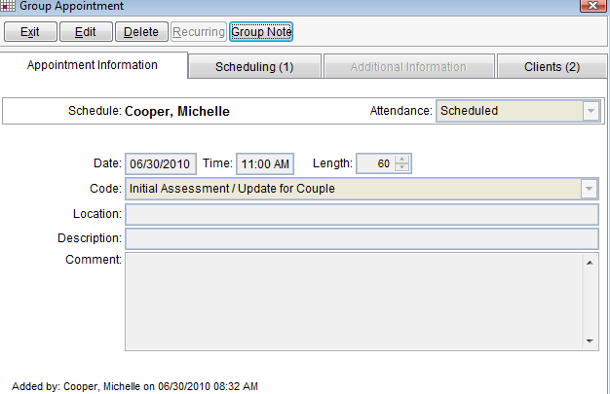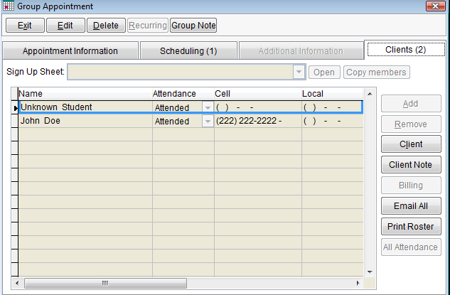
- Complete the Initial Assessment dataform and Dx for the first person. If you plan to “copy and paste” the narrative portion of the initial assessment report into both records, make sure that the last thing that you do before closing out the first note is to “copy” that section in the report. Return to the “Clients” tab.
- Select the second person to document and select the Client Note button on the far right of the screen.
- Go immediately to the section of the note where you wish to paste the narrative from the other person and paste it into that text box.
- Proceed with the completion of the Initial Assessment data form and Dx for the second person.
- Sign, forward and lock as appropriate.
- You will not distribute a note because you have created individual notes for each person.

How to add complete a termination note for couples clients.
At the end of couples counseling, you will need to create a termination note for each member of couple:
- Go to the client’s case file.
- Open “New Note” and select either “Termination / Transfer – Individual/Couples” or “Termination – No Ongoing Services” depending upon number of completed sessions.
- Click on “Edit”
- Select “Data Forms” tab and select “Termination / Closing A File.”
- Sign, forward, and lock as appropriate.

How to Use Form Letters
- In Titanium select open on the top tool bar and click on form letters. (If you already are using WORD, go ahead and close before accessing.)
- Once you select form letters a dialog box will appear and you will then select the appropriate letter by clicking the arrow on right which will display a list of possible letters.
- When the letter is selected you will then click on select client and the box will appear for you to enter the client student I.D. number and pick the appropriate client.
- Once you select the client you will notice in the forms letter dialog box next to the select client button the client’s name.
- When you are done selecting a form and client you will then click on the load form and client button. This will then take you into WORD where you will view the actual letter with the specific client’s information dropped in. **Note that some form letters require you to add additional information.
- You would then make any changes you feel appropriate for the specific circumstance.
- Once completed you will then print out on WCU letterhead.
- Check print out to make sure all is correct regarding alignment, etc.
- When you have completed the printing you will then close your WORD letter and a dialog box will appear asking you to save or not. DO NOT SAVE LETTER! We want to keep the letters in a specific format and we do not want to save any changes on top of the form letter.
- You will then close the form letters dialog box in Titanium.
- Make sure that you place a sticky note on the form letter with instructions regarding name, date, time and clip to the outside of the file for scanning procedures.

How to Send and Document E-mail to an Individual Client
Go to “Case Management Follow-up Section” of this manual for further instructions on how to send and document individual emails in Titanium.

How to Send and Document E-mail to a Group of Students
- In Titanium, create a group appointment called *Follow-up Email to Group of People during the time period where you are sending the group email.
- Go to the “Clients” tab and add the recipients to the list. (Note: If you already have a group of students created from a “Group Sign Up Sheet,” you can select the correct group under the “Sign Up Sheet” tab and then select “Copy members” to copy them into this appointment.
- Mark their attendance as “Attended” and select “Save.”
- On the right side of the screen, select “Email All” to activate Outlook for email purposes. A message box will appear which prompts you to either add the selected names into a “blind copy” email or copy and paste to the Windows Clipboard. You’ll also notice that the message box will alert you if there are any missing email addresses.
- In order to send an email in Outlook and protect everyone’s privacy, you’ll need to have the email addresses appear in the “blind copy” section of the email. However, in Outlook, a group e-mail must also have each email address separated by a semi-colon and a space (“; “). You’ll likely want to send the e-mail to yourself and make sure that all the email addresses are in the correct format before composing/sending the email.
- Once you’ve composed the message, make sure that the ‘counseling-related’ email signature is used before sending the group email.
- Check your in-box to verify that the message was sent and then document in each individual electronic record as described in the earlier “Case Management Follow-up Section” of this manual.

Supervision of Trainees

Responsibilities
Supervisors are responsible for monitoring their supervisee’s activities in Titanium. These include:
- Check their schedules to be sure that appointments are being scheduled appropriately.
- Checking their Task List periodically to be sure that items are not older than 7 days.
- Checking their My Clients list for:
  - Current client list (assigned clients are correct)
  - Client Attendance overview
  - Next Appointment/Last appointment
  - Days since last appointment – a good indicator for termination / follow-up needed

Reviewing Supervisee’s Notes
Supervisees may forward their notes to you at any time for your review. You need to communicate when you’d like to review them (unsigned, signed by the supervisee).

- Go to your task list. (all forwarded notes will appear on your task list)
- Review the note AND diagnosis as you prefer.
- Make a decision:
  - The note needs further work by the trainee:
    - Edit the narrative and/or diagnosis directly if the note is unsigned.
    - Forward it back to your supervisee with a short note in the “Forward To Note” field.
  - The note is complete.
    - Lock the note by signing on line 3.
- Click on Save/Exit.

Adding an Addendum to a Supervisee’s Note
From time to time, supervisors may want to add an additional note to an existing case note written by a supervisee. This is called an Addendum. To do so:
- Get to the Note: (My Clients, Case File, Open Note)
- Click on “Edit” and then click on “Addendum”.
- Type your addendum as appropriate.
- Sign and Lock
- Save and Exit

Scheduling Other Non-Clinical Activities

Adding Yourself to an Existing Appointment
Before adding an appointment to your schedule, determine if there are any other CPS staff members who will be present in the activity (e.g. supervision, staff meetings, campus support, outreach presentation/service provided.) If so, it is important that you DO NOT add another appointment to Titanium, but instead, add yourself to the existing appointment. Masters-level trainees will need to coordinate these schedule additions / changes through the Front Desk, due to security / clearance settings on their Titanium account. For all other CPS staff, here is how to add yourself to an existing appointment.

- Double-click in the appointment that you would like to add to your schedule.
- Select Scheduling tab to go to this screen.
- Select Edit.
- Select Add/Select on the right.
- Check the box next to your name and select OK.
- Then press Save and Exit.

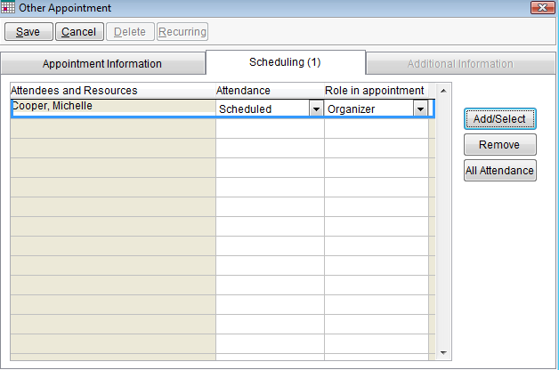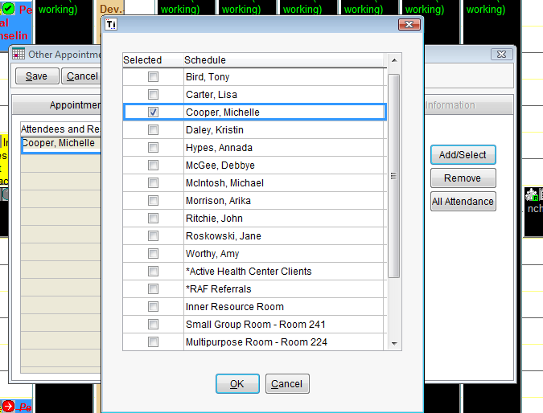

Placing A “Generic” Non-Clinical Activity in Your Schedule
A “Generic” Non-Clinical Activity is something that doesn’t need to be tracked for annual reporting purposes. These include staff meetings, lunch, consultation with only CPS staff members, prep work and holds, among others. Sometimes these are already added globally by the front desk (e.g. staff meetings, staff stress management) and other times they are managed by the individual. Trainees should follow the instruction of the Training Director with regard to training-related appointments to avoid scheduling problems.

- Consultation w/ CPS staff only | - Lunch | - Room Reservation
- Desk Coverage | - Out of Office (not working) | - Senior Staff / Intervision
- Hold | - Prep Work | - Research / Professional Issues
- Supervision of Senior Staff Provided/Received | - Staff Stress Management | - Staff Meeting
- Supervision Provided by PreDoc to Masters | - Intern Seminar Instruction | - Supervision of Supervision
- Supervision of Trainee Provided/Received | - Orientation Training Provided/Received

1. Right or left click at the time you wish to schedule an activity.
  - Choose add- “Other Appointment”
2. Verify time, date & length of activity
Titanium Timesaver Tip:
Create “hold” placeholder on non-occupied times (e.g. 7:00am) so you can create a visual “to do” reminder that won’t need to be marked as “attended.”

3. Under Attendance: click on “scheduled.”
4. Enter the Location on activity in Location.
- Place any specific description of the program or activity in Description
- Place any additional reminders in the Notes (optional)
- Then press Save and then Exit. Appointment will now appear on your schedule.

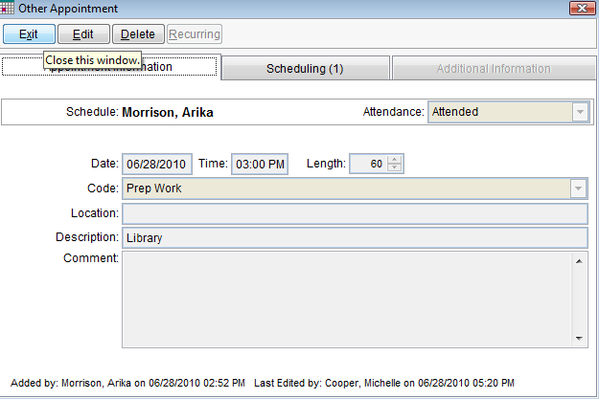

Placing A “Service-Related” Non-Clinical Activity in Your Schedule
A “Service-Related” Non-Clinical Activity is something that does need to be tracked for annual reporting purposes. These include outreach presentations, campus support, overtime, interview / recruitment contact among others. Sometimes these are already in Titanium (because another staff member is already doing the activity) and other times they are not. It’s important to add yourself to an existing appointment if you are performing a similar function at the activity. Otherwise, our data tracking will be inaccurate. Trainees should follow the instruction of the Training Director with regard to training-related appointments to avoid scheduling problems.

- Campus Support | - Consultation (including non-CPS staff) | - Prof. Dev.- Provided
- Committee Meeting | - Interview / Recruitment Contact | - Off-Campus Support
- Other (only if direct service) | - Outreach Presentation/Service Provided
 | - Consultation (with students only) | - Teaching – In Class Only

If the activity is already in the schedule and you will be serving the same function as your colleague, add yourself by first opening the appointment, select the “Scheduling” tab and check the box next to your name. If it is not in the schedule, follow the steps below:

1. Right or left click at the time you wish to schedule an activity.
  - Choose add- “Other Appointment”
2. Verify time, date & length of activity
3. Under Attendance: click on “scheduled.”
4. Enter the Location on activity in Location.
- Place any specific description of the program or activity in Description (Be as specific as possible; identify title of program/activity.)
- Place any additional reminders in the Notes (optional)
- Then press Save and then Exit. Appointment will now appear on your schedule.

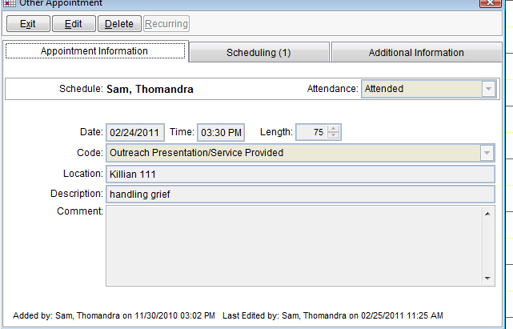

Appointment Codes Requiring “Additional Information”
Please note that some “Other” appointments require that the staff member enter the “Additional Information” section of the appointment screen. You will be prompted to complete the “Additional Information” on your Task List after you’ve attended the appointment, but not if the appointment is cancelled. There are two ways for you to complete this information. You can either wait until prompted by your “Task List” or you can manually enter the information directly to the appointment in your schedule.

After Service Is Completed:
1. Right click on the appointment in your calendar and then click Edit.
2. Under Attendance, verify the outcome of the activity (Canceled or Attended). If the activity is Canceled, do not complete anything further.
3. Verify that the Description line contains an accurate description of the activity (not in Comment box.)
4. Click on the button towards the right that reads Additional Information. This will toggle to the correct screen for data entry. Only the screens which are necessary to complete will be visible on the screen. If there are no options to select in a category (e.g. Outreach Subcategory), then leave the field blank. Make sure that every field that you can complete, IS completed.
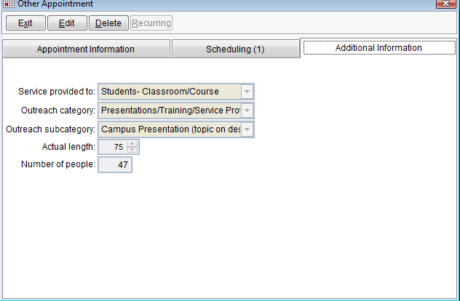

5. Status: Used ONLY for “Overtime.” This appointment is double-scheduled for any after-hours activity that is above and beyond your scheduled work contract. Make sure that the “overtime” appointment covers the same block of time as the work function appt. Indicate in the description line what activity is being done while ‘overtime’ and select type of activity from below:

- After Hours- Indirect / Paperwork | - After Hours – Counseling Direct / Clinical Consult
- After Hours- Campus Support/Consultation | - After Hours –Emergency Direct
- After Hours –Outreach Presentation/Training Provided

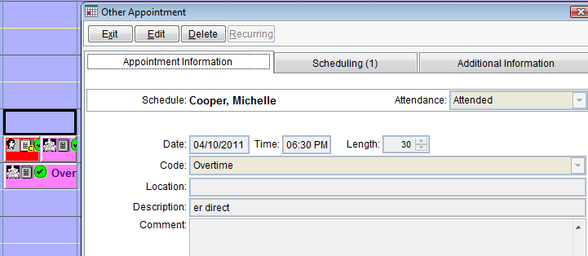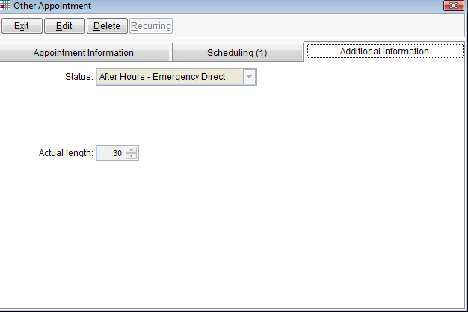

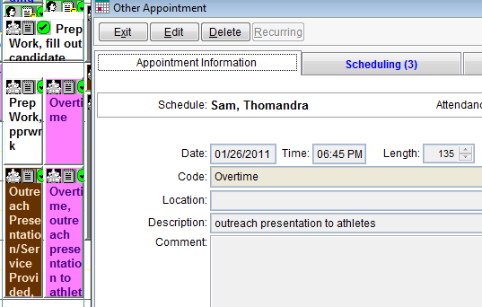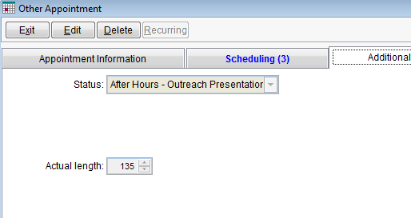
6. Service Provided To:

- CPS Staff | - Multiple Audiences | - Off-Campus Community
- Self | - Parent(s)/Family/Significant Other(s) | - Staff / Faculty / Administration
- Students- Other | - Students- Classroom / Course | - Students- Residence Hall
- Other

7. Outreach Category Use the table below to find the best descriptor of the activity and service that was provided through this activity.

- If you have entered Campus Support for the appointment code, select Support or Presence as Outreach Category.
- If you have entered Committee Meetings for the appointment code, select Committees Meetings.
- If you have entered Consultation (including non-CPS Staff) for the appointment code, select Consultation
- If you have entered Consultation w/Student(s) only for the appointment code, select Consultation
- If you have entered Interview / Recruitment Contact for the appointment code, select Candidate Interviews / Contacts.
- If you have entered Off-Campus Support for the appointment code, select either:
  - Consultation – you provided off-campus consultation as a representative of WCU and/or CPS.
  - Support or Presence – you attended an activity off campus and intentionally/visibly represented WCU and CPS.
  - Other Activity – if neither of the above fit.
- If you have entered Outreach Presentation for the appointment code, select Presentations / Trainings/Service Provided by you
- If you have entered Overtime, you will only complete the Status box that describes the type of overtime (not an outreach category.)
- If you have entered Professional Development Provided for the appointment code, select Prof. Dev. Provided by you.
- If you have entered Other (only direct service related) for the appointment code, select whichever category makes the most sense or Other Activity and notify Michelle as soon as possible about the activity so that a determination can be made whether or not to create a category.

8. Outreach Subcategories: Use the following tables to select the best option for the subcategories. If you find you must select “Other,” please notify Michelle immediately so that a determination can be made whether or not to create a new subcategory.

- Candidate Interviews / Contacts
Candidate Contact (CPS Intern / Staff), Candidate Contact (non-CPS Position)OR Candidate Contact (CLAW-related)

- Committees Meetings Notify Michelle ASAP if ongoing committee name isn’t listed on table below.

- AIDS Quilt Committee | - Alcohol and Drug Task Force | - Counseling Advisory
- DV/SART Case Conference | - Eating Disorders Treatment Team | - EMH Subcommittee w/i Wellness Council
- Employee Response Team (WVMT) | - Red Zone / Red Flag Committee | - Student Crisis Response Team
- Search- CPS Related | - Search- Not CPS-related | - Student Affairs Staff Development
- Welcome Week | - Threat Assessment Team | - Student Affairs Department Heads
  - Other (notify Michelle ASAP)

- Consultation (A targeted consultation issue supercedes the standard populations, so use dark green, if applies, first.)

- CLAW-Related | - Substance-Related | - Case Management- Related
- Intercultural-Related | - Admin / Dept. Consultation | - Clinical Consultation
- Student (Interview/Project) | - Other | - Athletic Department-Related

- Professional Development Provided By You

- Local Inservice / Training | - National, Regional & State Professional Presentations | - Service to the Profession- National, State or Regional Leadership
- Other | - Service to the Profession – Other Community / Local

- Presentations / Training /Service Provided By You For Info Tables (various events), specialized Campus Programs, indicate event on Description line of appointment. Then select appropriate coding (see dark green for typical outreach service at campus program.)

- CPS Services Overview | - Alcohol Awareness Week / NASD | - Campus Presentation (topic in description line)
- Info Table - CLAW | - Training (see description line) | - Eating Disorder Awareness Week
- Info Table- CPS | - Intercultural Affairs Program | - Wellness /REC Related (description line)

For example:
Description Line | Presentations / Training / Service Category
Alcohol Screenings NASD | Alcohol Awareness Week / NASD
Tabling RE: Alcohol Awareness Week | Alcohol Awareness Week / NASD
Valley BallyHoo | Info Table – CLAW
Valley BallyHoo | Info Table – CPS
Group Sell – Dr. Herzog’s Human Sexuality | CPS Services Overview
Stress Management | Campus Presentation (topic in description line)
Depression / Suicide | Campus Presentation (topic in description line)
Screenings / EDAW | Eating Disorders Awareness Week
Behind Closed Doors | Training (see description line)
Safe Zone Program training | Training (see description line)
Project Care training | Training (see description line)
Take Back the Night | Intercultural Affairs Program
Transaction Day Panel Presentation | Intercultural Affairs Program
AIDS Quilt Debriefing | Intercultural Affairs Program
Wellness Carnival tabling | Wellness / REC Related
Stress Free Cullowhee | Wellness / REC Related
Tunnel of Oppression for RAs | Training (see description line)
Tunnel of Oppression for campus | Intercultural Affairs Program

Support or Presence

- CLAW Activity | - Alcohol / Other Drug Related | - Eating Disorder / Body Image Related
- Campus Rec & Wellness | - Off Campus | - Orientation Activity
- Intercultural Affairs Activity | - Student Affairs Program / Initiative | - University Wide Chancellor Program
- Other Activity

- Other Activity Select Other Activity or leave blank.

8. Actual Length: Enter in the time spent attending a meeting or providing a Service

- Number of People: If you provided a service, enter the number of people who were in attendance. If more than 1 CPS staff member was engaged in the activity, estimate the total number of people who were present during the activity / engaged with CPS staff.

- Toggle back to the Appointment Information screen and review to make sure that the appointment is marked “attended,” that there is a description of the title of the activity. Then press Save and then Exit.

Changing Your Password in Titanium Schedule
In accordance with the WCU Password Policy, you will be prompted every 90 days to change your password. When this occurs, we recommend that you also change your Titanium Schedule password at that same time. Here are the instructions on how to accomplish this password change.

1. Follow the instructions when prompted to change your WCU password. Make sure that you select a password that is over 8 characters long, contains lowercase letters, uppercase letters and either numbers or symbols. For example, you might select one of these options:
LETmeIN1 or Lifeisgood!!

2. Open Titanium Schedule. At the Login Account Status box (which appears every time you start Titanium Schedule), select the “Change Password”
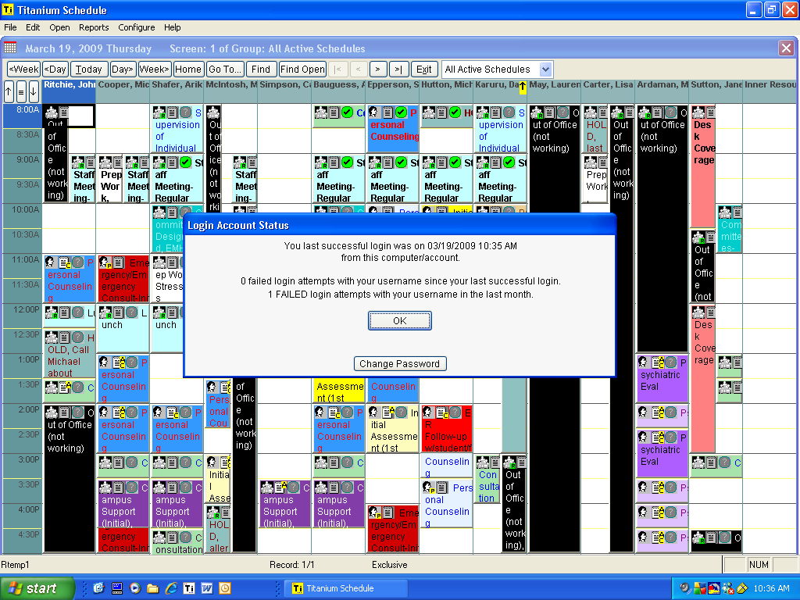

3. At the Change Password for: (username) box, type in your old Titanium Schedule password. Enter the newly created password (that you just created for the WCU password) twice. Then select OK.
