|  |  |  |  |
| --- | --- | --- | --- |
| **Reviewed By** | **Role/Responsibility** | **Signature** | **Date** |
|  |  |  |  |

Contents

1. Introduction 1

2. Purpose 2

3. Scope 2

4. Minimum Requirements for UB Biorepository Policy Compliance 2

5. Management Responsibility 3

6. Quality Standard 4

7. Biorepository Contact Information 4

8. Biorepository Infrastructure Overview: 6

9. Quality Control/Quality Assurance Equipment 9

10. Services and Rates 10

11. Requesting Biorepository Service: 16

## Introduction

The University at Buffalo Biorepository is a business entity providing biobanking services including controlled cold storage and processing of biological materials for research purposes. The UB Biorepository is a NYS-DOH licensed Tissue Bank. The UB Biorepository focuses on strong customer service within an environment that has safety as a first priority, protects the customer’s privacy, and fosters continual improvement.

The UB Biorepository is committed to serving the research community and industry partners by providing high-quality biomaterials to support basic science, clinical research, diagnostic development, creation of new therapeutics and technology development through centralized and standardized services for the collection, processing, management, and distribution of biobanking assets.

## Purpose

This manual describes the organizational structure, business overview, operational processes, workflows, management responsibilities and facilities of the UB Biorepository.

This manual defines our business operations and capabilities to internal and external customers as well as describes the equipment and infrastructure implemented for high quality biosample processing and management.

## Scope

The policies stated in this manual apply to all operations and activities within the UB Biorepository. All employees are responsible to follow policies and procedures and to help strive for continuous improvement in all activities and processes of the UB Biorepository.

|  |  |
| --- | --- |
| **Site Information:** | **Role** |
| University at Buffalo-Biorepository  Clinical and Translational Research Center (CTRC)  Room 6071  875 Ellicott Street  Buffalo, New York 14203 | Biorepository  <http://biorepository.buffalo.edu/>  Contact  [Biorepository@buffalo.edu](mailto:Biorepository@buffalo.edu)  716-881-7971 |

## Minimum Requirements for UB Biorepository Policy Compliance

As per the UB Biorepository Policy (add date published) there are minimum standards required for investigators to procure, process and store biomaterials within their own laboratories. The minimum requirements have been established to help ensure compliance with both academic and industry standards as well as provide visibility to all biomaterials at UB. The UB biorepository staff are available to consult on these requirements in addition to providing planning and implementation support for those investigators committed to supporting their own biobanking infrastructure at UB.

* Register all biomaterials in UB biorepository LIMS with Standard PREanalytical Code (SPREC) as per the International Society for Biological and Environmental Repositories (<https://www.isber.org/page/SPREC>)
* Provide SOPs for sample collection, processing and storage in UB Biobank format (template to be provided by UB Biobank staff upon request). Investigators will have access to UB Biorepository SOPs for reference
* Demonstrate a basic quality assurance process for recording sample deviations at the time of collection, processing or storage event recording
* Follow Good Laboratory Practice (GLP) and operate under the guidelines set forth by the College of American Pathologists (CAP) for all biosample activities.
* Demonstrate both physical and digital chain of custody for all sample collections, processing and storage. In the absence of a LIMS system or sample management software, this activity can be performed manually or via an approved Excel template which can be provided by the UB Biorepository
* Maintain temperature records for all environmental chambers that store biomaterials.
* Demonstrate a disaster recovery plan for failure of environmental chambers for all stored samples

## Management Responsibility

The UB Biorepository Management Committee (UBBMC) will meet monthly to monitor, on a regular basis, the progress of the Biorepository, its procedures, records, efficacy and quality of operations and any positive and negative feedback received from participants, staff or other stakeholders. Adverse outcomes and major procedural changes must be reported to the management for review.

The UBBMC will work with researchers who wish to bank biospecimens or utilize banked biospecimens from the UB Biorepository. The UBBMC will have policies and procedures relevant to the Biorepository and will endeavor to ensure adherence. The Committee will also oversee the appropriate use of biospecimens and administer over any conflicts of interest or complaints.

The UB Biorepository Management Committee (UBBMC) will be comprised of an Executive Director, Medical Director, Associate Director, Quality Manager and Lab Manager.

The Biorepository Manager or delegate is responsible for all UB Biorepository operations including compliance with current national, state and local regulations. The Manager will also ensure the Biorepository operates within budget and serve as a liaison to key users. Personnel authorized and supervised by the UB Biorepository Manager for biological sample procurement, processing, and data collection must familiarize themselves with all standard operating procedures (SOPs). Each employee is responsible for ensuring that all procedures are performed as defined in the individual SOPs.

The Quality Manager is responsible for implementing the Quality Management System (QMS) for maintaining and ensuring compliance of the UB Biorepository to all national and international regulations and accreditation. The quality manager will also be responsible for training all employees on GxP and perform gap analysis on quality systems. Internal audits will be performed by the Quality Manager at predetermined intervals.

## Quality Standard

The Biorepository has implemented an Enterprise Quality Management System (eQMS) utilizing the Assurx software platform to ensure that current good practice is in place with documentation and traceability while complying with 21 CFR Part11 requirements. These quality standards include a secure, limited access facility where personnel are trained in all procedures which are documented. Internal audits are conducted; policies and procedures are documented in SOPs approved by the Manager and updated using strict document control rules. Records are maintained electronically with the respect to purchase of new equipment, maintenance and repair activities and equipment disposal. Records are maintained for critical materials such as item purchased, date of purchase, expiration date and material safety datasheets (MSDs) where appropriate. Deviations to SOPs are recorded. More information on Quality process and procedures are described in the Quality Manual.

## Biorepository Contact Information

The operational hours of the Biorepository is Monday- Friday , 8 am-4pm with on call service provided if needed to receive any samples that are delivered after business hours. For general inquiries the biorepository team can be contacted at **Biorepository@buffalo.edu.**

**Organizational Chart**

|  |  |  |  |
| --- | --- | --- | --- |
| **Contact** | **Responsibility** | **Phone** | **Email** |
| Dr. Norma Nowak  contracts | Executive Director | 716-881-8903 | [njnowak@buffalo.edu](mailto:njnowak@buffalo.edu) |
| Dr. John E. Tomaszewski | Medical Director | 716-829-2846 | [johntoma@buffalo.edu](mailto:%20johntoma@buffalo.edu) |
| Dr. Donald Yergeau | Associate Director | 716-645-9195 | [donaldye@buffalo.edu](mailto:donaldye@buffalo.edu) |
| Arvind Ramaswamy | Quality Manager | 716-881-7971 | [arvindra@buffalo.edu](mailto:arvindra@buffalo.edu) |
| Melissa Hagen | Project Support Specialist | 716-249-1009 | [Mk38@buffalo.edu](mailto:Mk38@buffalo.edu) |
| Julio Guerra | Lab Manager | 716-533-2957 | juliogue@buffalo.edu |

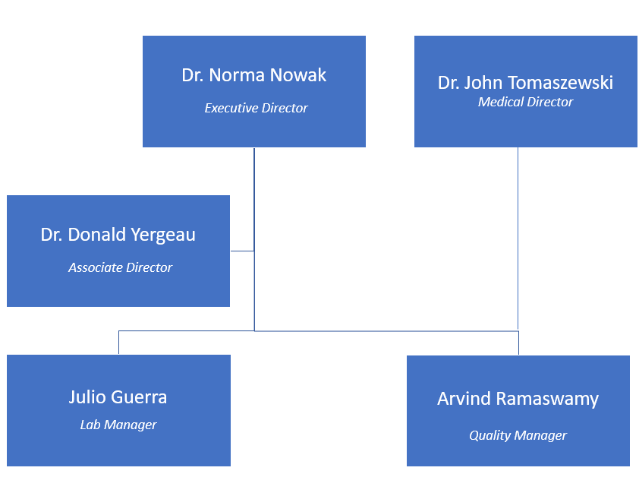

## Biorepository Infrastructure Overview:

The UB Biorepository has been provided 2000 Sq.Ft of space in the CTRC that is sufficient for all biorepository operations performed with diligent adherence to standard operating procedures. The laboratory space allows for storage of all types of applicable biospecimens and for any length of time allotted by the protocol or assigned biospecimen consent. The CTRC building and laboratory are restricted to authorized personnel through electronic key card access.

**Equipment:**

**Ultra-Low Temperature Freezers ( -80°C)**

The UB Biorepository currently has ten -80°C ultra-low freezers with the capacity to house 20 additional freezers. All units are validated and temperature is continuously monitored 24 hours a day through the Rees Monitoring system.

* **Brand/Model#:** Panasonic MDF-U76VA-PA
* Capacity: 25.7 cu. ft. / 728L (WHO recommended utilization factor is 0.67) = 487.76L
* Area Footprint (nominal): 9.51 sq. ft.
* Door(s): 1 exterior; 2 interior
* **Storage Capacity**:
* 576 standard 2” boxes (57,600 x 2ml vials)
* 384 standard 3” boxes (38,400 x 4ml vials)
* 3,456 standard microplates with foil tape
* 2,596 standard microplates with cover lid
* Temperature Range: -50°C to -86°C (in 1°C increments)

**-20°C Freezers**

The Biorepository has two -20°C Freezers with continuous temperature monitoring through the Rees Monitoring system.

* Brand/Model#: Frigidaire FFFU17M1QWE
* **Capacities:**
* Total Shelf Area (Sq. Ft.): 11.25
* Capacity (Cu. Ft.): 16.6

**4°C Refrigerators**

The Biorepository has two 4°C refrigerators with continuous temperature monitoring through Rees Monitoring system.

* Brand/Model#: Frigidaire FFRU17B2QWD
* **Capacities:**
* Total Shelf Area (Sq. Ft.): 11.25
* Capacity (Cu. Ft.): 16.6 (WHO recommended utilization factor is 0.67)= 314L

**Liquid Nitrogen Storage BioStore™ III Cryo -190°C System**

The UB Biorepository contains one Liquid nitrogen storage system with built-in comprehensive inventory management system and LIMS connectivity. The system combines Chart MVE’s proven, high-efficiency LN2 stainless steel freezer with Brooks automation technology and software to ensure the highest sample integrity. The BioStore III Cryogenic storage system offers the greatest sample protection with comprehensive inventory management and control with a superior user experience. Targeted and non-targeted samples are protected from warming above Tg (glass transition) throughout sample retrieval. Quality is assured by viewing user access, sample inventory, history, and audit-trail reports.

Emergency situation protection provides greater than 20 days of temperature stability in the case of energy or LN2 loss

**Cryopod Carrier**

The LN2 vapor-based CryoPod™ Carrier provides a safe, portable, and trackable solution for hand carrying temperature-sensitive biological materials. The CryoPods hold samples at ≤-150°C for over 3 hours and displays real-time temperature. The CryoPod logs temperature, date and time to ensure monitored sample control. It is also enabled with an audible and visual temperature alarm should there be a temperature fluctuation.

**Hamilton Microlab Star**

The Biorepository has two Hamilton Microlab Star units for automated liquid handling. One unit (Hamilton EasyBlood System) is dedicated to blood fractionation and the other unit (Hamilton Star) is dedicated to handling urine samples. The units can be reprograamed to aliquot other biological samples as well.

Hamilton's proven pipetting technology achieves high accuracy, precision, and repeatability from sub-microliter to large volumes, thus ensuring process quality. The Hamilton EasyBlood System provides integration of imaging and liquid level sensing technologies to reproducibly separate sample fractions with complete accuracy and no risk of contamination. There is also a built in barcode reader for both source/input tubes and destination tubes to track parent/child tube relationships. The Hamilton star system for liquid handling can handle any size or shape containers and also has a built-in barcode reader to track tubes.

**Perkin Elmer Chemagic 360**

The Perkin Elmer Chemagic 360 provides fully automated isolation of DNA/RNA using magnetic bead technology. The Chemagic™ 360 instrument enures high yields of ultra-pure nucleic acids suitable for a wide range of downstream applications such as NGS, MLPA, genotyping, and PCR. The UB Biorepository currently has two Perkin Elmer Chemagic 360 instruments to meet high throughput processing projects.

## Quality Control/Quality Assurance Equipment

**Lunatic**

The LUNATIC by Unchained Labs is used for quantification and extrapolating contamination profiles in a given sample. The Lunatic provides analytical quality control of DNA, RNA and plasma samples using microfluidic technology.

**Fluidigm BioMark**

The Fluidigm Biomark is used for functional and analytical quality control using SNPtrace technology. DNA samples that come through the UB Biorepository are assayed on the Fluidigm Biomark and compared to all other DNA samples to confirm sample quality and check for cross contamination. Functional quality is also established through the SNPTrace panel which interrogates regions known to affect sample quality in downstream analyses.

**Agilent TapeStation**

The Agilent 4200 TapeStation system is an automated electrophoresis tool for DNA and RNA sample quality control. Fully automated sample processing enables the unattended analysis of size, concentration and integrity. The TapeStation can process up to 96 samples in a single run.   
  
The TapeStation system provides a complete solution for true end-to-end sample quality control within any next-generation sequencing (NGS) or Biorepository workflow. This covers the full DNA (genomic and NGS libraries) and RNA (total and small) range and offers high levels of flexibility in a simplified workflow with ready-to-use ScreenTapes.

**Rees Scientific- Temperature monitoring:**

The temperature (HVAC units) and humidity are controlled and monitored through the Rees system. All temperature and humidity records can be accessed from the Rees system. The humidity and temperature sensitive equipment in the lab must be operated between 20-80% humidity and 15ᵒC-25ᵒC. The lab has adequate air circulation and ventilation for the use of dry ice. The heat from the freezers are also recirculated during winter months for maintaining adequate lab temperature. All of the liquid nitrogen tanks are located inside the lab in an area with sufficient space so that if the liquid nitrogen were to spill over, oxygen deprivation would not be a concern. Oxygen sensors in the room connected to the Rees system will also sound alarm and notify the manager.

The Rees monitoring system provides 24/7 monitoring of all samples in the freezers. The Rees monitoring system is also hard wired to call the biobank manager or the quality manager’s personal phone in case of predictive drop in temperature of cold storage systems. This enables quick response time and provides sufficient lead time to transfer the samples to other freezers in case of emergencies.

**Assurx – Enteprise Quality Management System**

UB Biorepository maintains electronic quality records to demonstrate conformance to specified requirements and the effective operation of the Business Management System. Control provides for the identification, collection, indexing, filing, access, storage, maintenance, and disposition of quality records. Pertinent customer or supplier records are an element of these data. The quality records are stored electronically in AssurX system,

All quality records are legible and are stored and retained in such a manner that they are readily retrievable. Storage facilities provide an environment that minimizes damage, deterioration and prevents loss. Retention times of quality records are established and recorded.

Assurx system is also used for tracking non-conformance, Corrective and preventive actions, training and internal audits.

## Services and Rates

The Biorepository provides the following services for research and industry partners:

* Short Term/Long Term storage at (**-20°C, -80°C, Liquid Nitrogen -196°C) including** Cryopods for Immediate sample transfer at **-196°C**
* DNA/RNA Extraction
* Automated Blood Fractionation and Liquid Handling
* GLP compliant collection Kits
* Analytical and Functional Quality Control Checks

The table below provides the current rates for services provided by the UB Biorepository. For more information, the clients can email the team at [biorepository@buffalo.edu](mailto:biorepository@buffalo.edu).



**Collection Kits:**

The UB Biorepository can create customized kits for collection of biospecimen samples depending on study design and requirements. The customized kits are GCP/GLP compliant and will be tracked through the LIMS system where a complete inventory will be maintained, including the parent child relationship of all tubes used to create a kit. All kits will be uniquely barcoded for efficient downstream processing and monitoring.

**Biospecimen Processing:**

The UB Biorepository offers GLP compliant processing services, including blood fractionation, DNA/RNA extraction followed by analytical and functional quality control checks. Automated liquid handlers will be used to process blood and aliquot the various fractionated components into barcoded Fluidx tubes. These aliquoted samples will be stored at ultra low temperature for further downstream processing and distribution. The overall process workflow is provided in the schematic below.

**Laboratory Inventory Management System (LIMS)**

The Biorepository established a validated Laboratory Information management system (LIMS) compliant with 21 CFR Part 11. LIMS allows us to effectively manage samples and associated data through automated workflows, equipment integration, and record keeping. Quality and security of samples are assured through standardized workflows, tests and procedures, while providing accurate controls of the process. Detailed information of samples are recorded when the sample is created or first arrives in the lab, which can be enhanced and expanded throughout its lifecycle. This normally includes the source of the sample, type of sample, the names of the lab researchers working on it and which parts of the workflow it has passed through. It also includes information such as how it should be stored and any expiration dates. LIMS reduces the risk of a sample becoming lost, contaminated or expiring. LIMS also provides an integrated shipping and distribution module to keep track of samples that have been retrieved and shipped to respective Principal Investigators along with a manifest.

**Accessioning Workflow**:

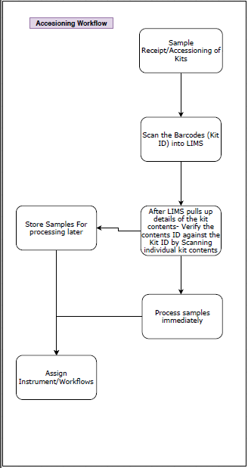

**Nucleic Acid Extraction Workflow:**

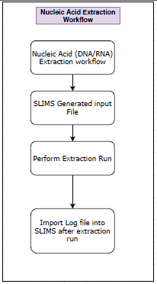

**QC Check Workflow:**

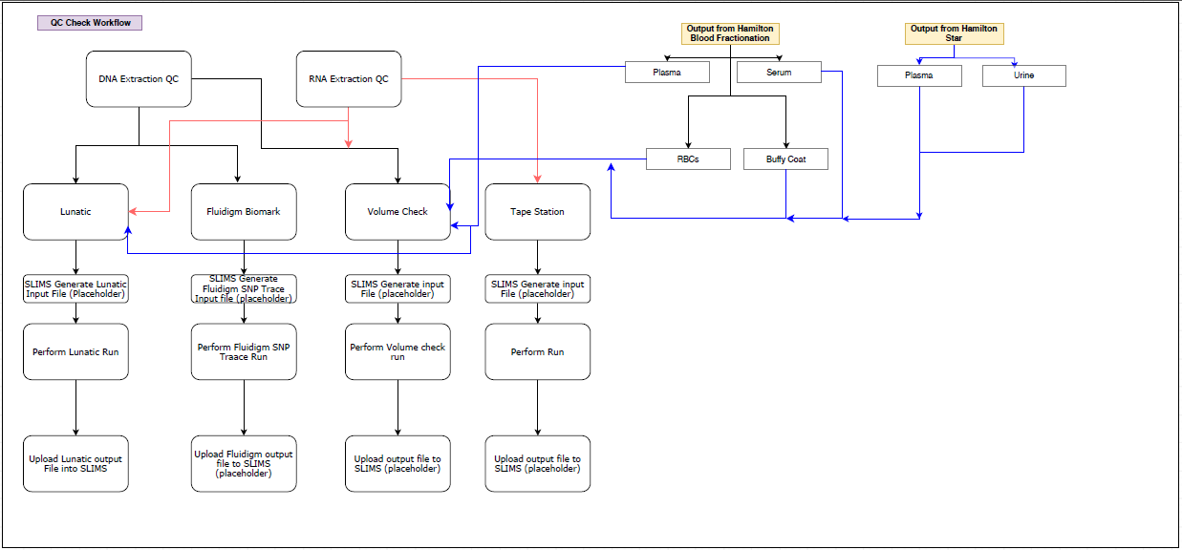

## Requesting Biorepository Service:

To request biorepository service and for general inquiries, all clients must send an email to [biorepository@buffalo.edu](mailto:biorepository@buffalo.edu). One of our team members will get in touch through e-mail to discuss the project needs and setup a virtual meeting. A statement of work will be written to establish the details of the project.

**Logistics for Receiving and Delivering Local samples**

For local samples (within Buffalo, NY), the biorepository works with 123 delivery services to arrange for sample pickup or one of our team members can personally pickup the samples. Prior to shipping samples, all clients must complete the Chain of Custody form available on the

<http://biorepository.buffalo.edu/>.

All clients must provide evidence that a consent has been obtained for all samples stored in biorepository. Evidence can be in the form of written letter attested by Principal Investigator and can be sent via email to [biorepository@buffalo.edu](mailto:biorepository@buffalo.edu). All samples shipped to the biorepository must have tracking information and inventory list to ensure the samples meet incoming quality checks. Clients are responsible for shipping the samples safely and securely to the biorepository

**Logistics for Receiving and Delivering Domestic Samples**

For domestic samples (within U.S), the clients are responsible for shipping safely and securely. Prior to shipping samples, all clients must complete the Chain of Custody form available in the *Biorepository website* . All clients must provide evidence that a consent has been obtained for all samples stored in biorepository. Evidence can be in the form of written letter attested by Principal Investigator and can be sent via email to [biorepository@buffalo.edu](mailto:biorepository@buffalo.edu). All samples shipped to the biorepository must have tracking information and inventory list to ensure the samples meet incoming quality checks.

**Sample Acceptance and Accessioning**

All samples received by the biorepository will have identifiers removed and replaced by a biorepository code to protect PHI. Each sample will have a unique sample ID, however, a link between the sample ID and the parent sample ID will be maintained. It will be possible to use the unique ID to re-identify the parent sample. The samples are therefore referred to as reidentifiable (see below). For the purpose of these SOPs, the following definitions are applied per the National Statement on Ethical Conduct in Research Involving Humans (2007, updated in 2015) (NS):

• individually identifiable data, where the identity of a special individual can

reasonably be ascertained. Examples of identifiers include the individual’s

name, image, date of birth or address;

• re-identifiable data, from which identifiers have been removed and replaced by

a code, but it remains possible to re-identify a special individual by, for example,

using the code or linking different data sets;

• non-identifiable data, which have never been labelled with individual identifiers

or from which identifiers have been permanently removed, and by means of

which no special individual can be identified.

**Sample Processing:**

All sample processing will be completed per agreed upon SOW and as per GLP standard using specific SOPs. New inventory will be created to record genealogy of samples (if applicable) using the LIMS system. Clients may request a copy of the inventory through email to biorepository@buffalo.edu.

**Sample Retrieval:**

All requests for sample retrieval should be sent to [biorepository@buffalo.edu](mailto:biorepository@buffalo.edu) by completing the *sample retrieval request form*. All samples shipped from the biorepository will be tracked and a shipping manifest will be attached to the shipment. The shipping quote will be provided to the clients prior to shipping the samples.